Image | 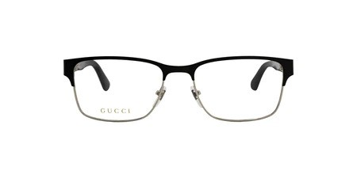
Brand | GUCCI
Model Name | GG 0750O
Price | RS 1800
PRODUCT DETAILS

